Contents
Problem Framing & Data Understanding 1
What is the problem being solved? 1
What is the target variable? 2
Is it binary or multiclass classification? 2
Challenges do you expect (e.g., imbalance, noise) 2
Class Imbalance: 2
Large range between attributes: 2
Categorical Noise: 2

Problem Framing & Data Understanding

What is the problem being solved?
The model is trying to predict whether a customer will pay on their next month payment time using their credit limit, demographic information, bill amounts, and previous payments.

What is the target variable?
The target is to predict of the person will pay at the time or not
- 1 = No, the client
- 0 = Yes, the client

Is it binary or multiclass classification?
It is a binary classification problem, because the target has only two classes, whether the person will pay at the time or not

Challenges do you expect (e.g., imbalance, noise)

Class Imbalance:
Approximately 78% of the records represent clients who did not default while only 22% represent those who did This skew can lead a model to be overly optimistic, achieving high accuracy by simply predicting "no default" for everyone while failing to identify the high-risk individuals the bank cares about.

Large range between attributes:
The dataset contains variables with BIG DIFFRENCE in scales. For instance, credit limits (LIMIT_BAL) and bill amounts reach into the hundreds of thousands, while ages and payment statuses are in double or single digits. Without proper normalization or standardization, the mathematical weight of the larger numbers would dominate the model's learning process.

Categorical Noise:
Columns like EDUCATION and MARRIAGE contain undocumented values (such as 5 or 6) that fall outside the defined data values in the repository. These require careful remapping or grouping to prevent the model from treating "unknown" data as distinct, influential categories.

Data Acquisition & Documentation

Dataset source (link)
https://archive.ics.uci.edu/dataset/350/default+of+credit+card+clients

Any modifications made (cleaning, label changes, training/test splits)

Cleaning
We removed the ID column, as it does not provide any useful information for the model. Additionally, we cleaned the dataset by eliminating noisy records. For example, the marriage attribute contained 54 entries with an invalid value of 0, and the education attribute included inconsistent values such as 0, 5, and 6. Since the dataset is relatively large (30,000 records) and these noisy entries represent only a small fraction (around 1.75%), we chose to remove them to improve data quality
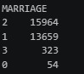
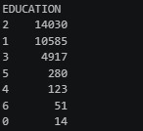

Label changes

We renamed the attributes from X0, X1, X2, …, X23 to more meaningful names based on the repository description. In addition, the monthly delay attributes were inconsistent because they included PAY0 and PAY2 but skipped PAY1, so we corrected the numbering to PAY1, PAY2, …, PAY6.

Training / test splits

We have used K-Fold-cross validation for making the model and we k = 5

Data Cleaning & Preprocessing

Handling missing values
There was no missing value on the data for the categorical or the numeric features based on the repository
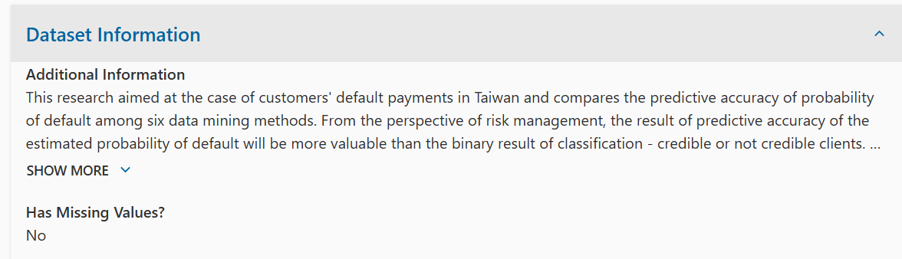

Encoding categorical variables
The data (categorical) was already encoded to numbers based on the repository the data like the sex marriage and the educations was mapped to numbers these numbers
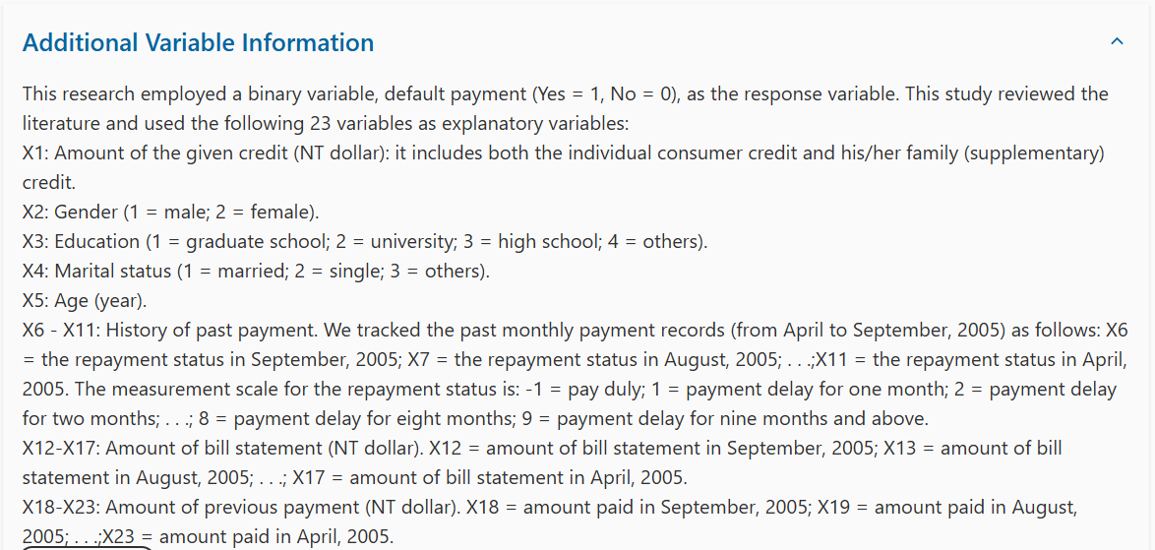

Since we are using the KNN model as a classifier and it relies on distance calculations to assign data points to class 1 or class 2 it can be biased by features with larger numerical values. In categorical features, these numerical differences do not represent any real-world ordering or importance for example being male or female does not imply a higher or lower value. Therefore, we apply one-hot encoding to these features to ensure that all categories are treated equally and do not unfairly influence the distance calculations.

Scaling numerical features (if needed)
We have used Robust scaling for the normalization of the large data and we used it as it don’t depend on the outliers ( depend on the median of the data ) unlike the normalization techniques that rely on the mean of the data which will be smash the small data also we have used it because it is insensitive for the negative value unlike the log transform
$$x_{i}=\frac{x-Mⅇⅆⅈan}{IQR}$$

Handling class imbalance (if needed (
We used the SMOTE (Synthetic Minority Over-sampling Technique) to oversample the minority positive class and used a sampling_strategy parameter of 0.5 so that after oversampling the positive class would be 0.5 * the size of the negative class decreasing the imbalance between the two classes without altering the dataset too much avoiding corrupted results.
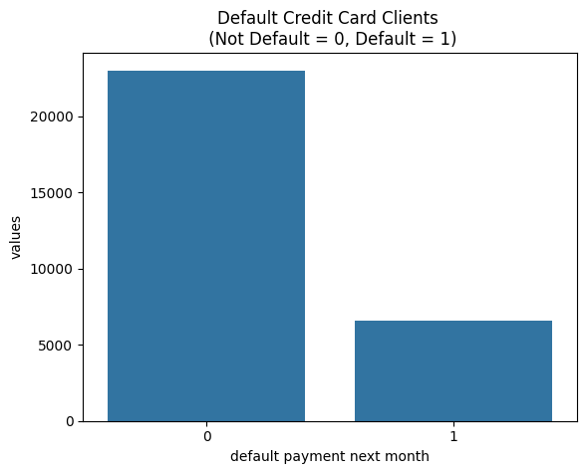

Relation between Limit Balance and output classes
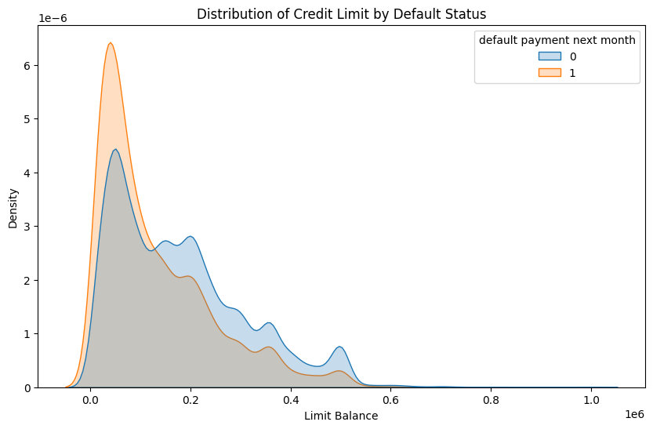
We can see here that by the bank increasing the bill limit the risk of having people who doesn’t pay their debts on time increases it’s clear how the number of people drops in a general decreasing trend with increasing the limit balance while the number of people who doesn’t pay tends to shoots up with increasing limit balance and generally has a slower dropping trend than the number of people who pay in the region between 0.1 -> 0.6.

Heat Map

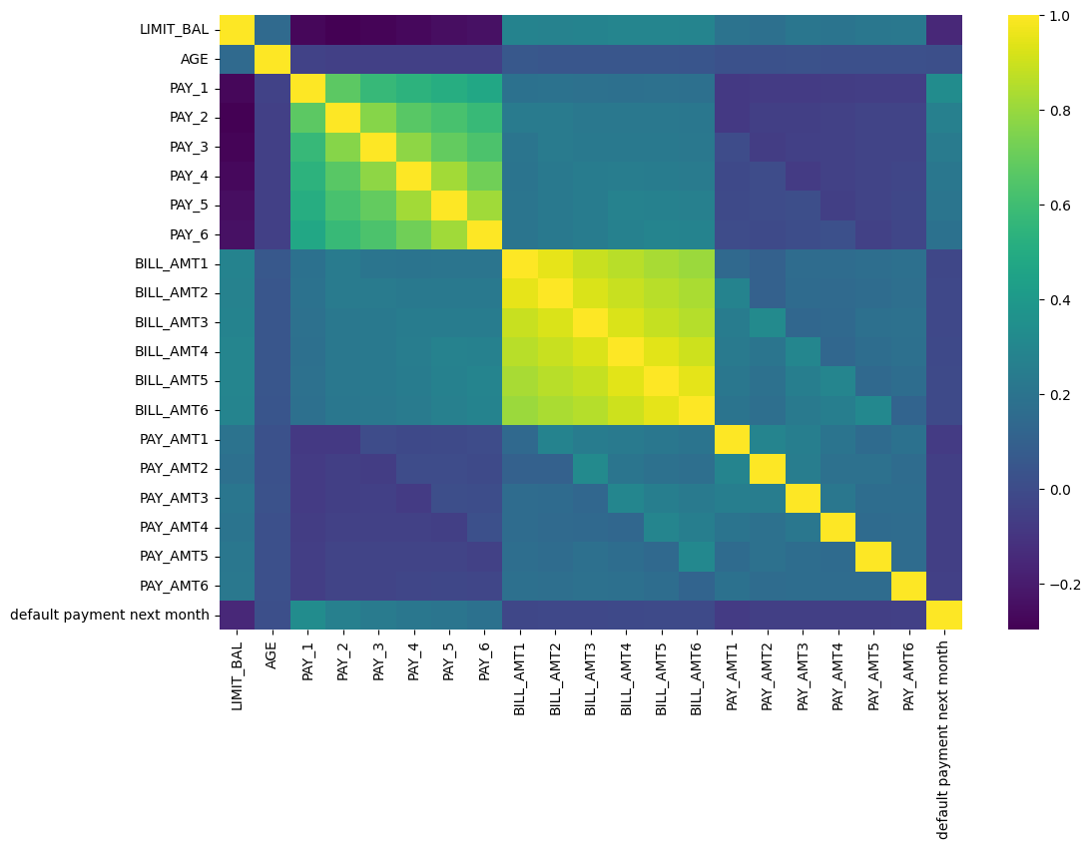
Conclusions:
- Behavioral Consistency:
Someone who is late one month is more likely to be late the next month and to have been already late on the prior month.
- Age is not much of a key factor here. Balance limits and payment history are much stronger predictors to the behavior of clients in the future.
- There is a high correlation between the Balance limits amounts on the six months. Same goes for the payment history of the last six months they. All of these carry almost the same information.

